Math 32

Lecture 2: Inclusion-Exclusion

Example 1: Consider rolling one six-sided die. For each of the following events, list their possible ways and find their probabilities.

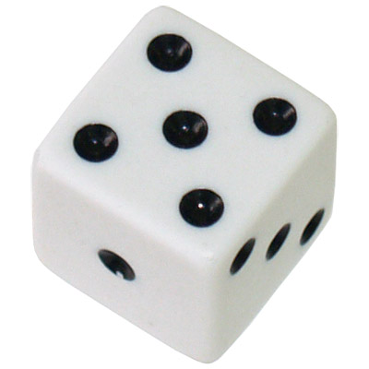

For probability notation, ***events*** are usually denoted in capital letters. (This will make later descriptions and formulas easier to write.)

* Let A: rolling an even number

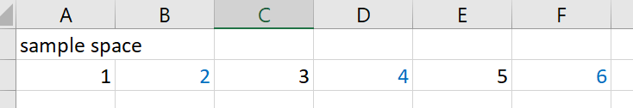

The probability of A, the probability of observing an even number is 3/6, or ½

P(A) = 3/6

* + (aside: no need to reduce fractions in Math 32)
* Let B: rolling a number greater than 3
  + True if data x > 3

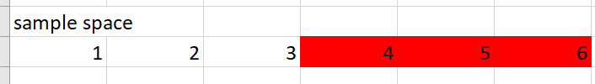

The probability of B, the probability of observing a number greater than 3 is 3/6

P(B) = 3/6

* Let C: rolling a double-digit result

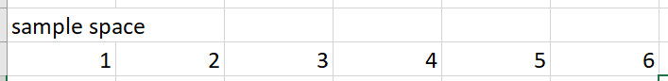

Since there are no possible outcomes that meet that description, we say

P( C ) = 0

We will now try to solve P(A or B). That is, what is the probability of observing an even number or a number greater than 3?

* A = {2, 4, 6}
* B = {4, 5, 6}

We start out with P(A or B) = P(A) + P(B) = 3/6 + 3/6 = 100 percent??

* But the answer is clearly not all 100 percent
* Chat query: what went wrong?
  + Observe: a couple of the items were counted twice
  + We need to be careful with the intersection
* Intersection (set of values that appear in both A and B)
  + A and B = {4, 6}
* Union (set of values that appear in A, B, or both)
  + A or B = {2, 4, 5, 6}
* Key idea: we need to subtract the overlap

Inclusion-Exclusion Principle

$$P\left(A or B\right)=P\left(A\right)+P\left(B\right)-P(A and B)$$

P(A or B) = P(A) + P(B) – P(A and B) = 3/6 + 3/ 6 – 2/6 = 4/6

Example 2: 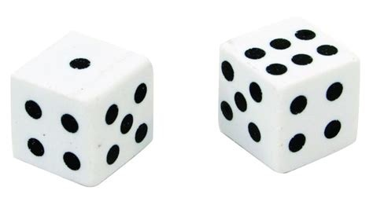

Consider rolling two, six-sided dice. Find the probability that their total is 8 or the second die shows a number greater or equal to 5.

Define the events

* A: total is 8
* B: second die shows a number >= 5

Compute

* P(A) = 5/36
* P(B) = 12/36

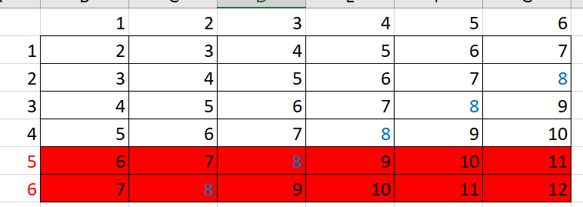

Inclusion-Exclusion

P(A or B) = P(A) + P(B) – P(A and B) = 5/36 + 12/36 – 2/36 = 15/36

* Tip: when we encounter the signal word “or”, consider using this Inclusion-Exclusion formula

Definition: Two events A and B are ***disjoint*** if there is no intersection

$$P\left(A∩B\right)=0$$

Shiny app demonstration

<https://dsollberger.shinyapps.io/inclusionExclusion/>